The Big Lie Of 2020

The Real ‘Big Lie’ Of 2020 Had Nothing To Do With The Election And Was Far More Damaging

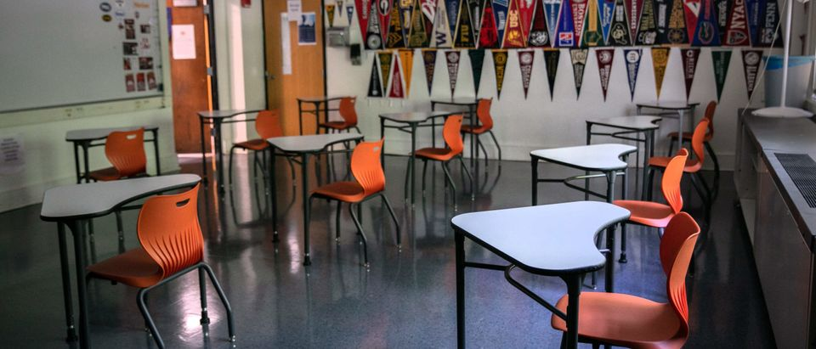

(Photo by John Moore/Getty Images)

[JORDAN LANCASTER](https://dailycaller.com/author/jordanlancaster70@gmail.com)REPORTER

June 13, 2021-8:46 PM ET

The media has spent the past few months talking about the “big lie” that former president Donald Trump spread about the election being stolen. But the consequences of that – while not good – don’t compare to the consequences of the lies that were spread about COVID-19.

After it was declared that President Joe Biden won the 2020 election, Trump began claiming that the election was stolen and that he was the true winner.

[**(RELATED: The Very Real Harm Our COVID-19 Policies Are Doing To Our Kids)**](https://dailycaller.com/2020/12/15/covid-policies-harming-children-kids/)

Spirit Airlines [allegedly](https://dailycaller.com/2021/04/05/megyn-kelly-family-kicked-off-plane-spirit-airlines/) kicked a family off a flight because their two-year-old child was not wearing a mask while eating, and a four-year-old child with nonverbal autism was also [reportedly](https://dailycaller.com/2021/03/16/4-year-old-with-autism-kicked-off-plane-for-not-wearing-a-mask/) forced to get off a Spirit Airlines flight over not wearing a mask.

Forcing small children to wear masks, kicking families off of airplanes, closing our schools, and locking down the country has had dire consequences. Adolescent suicide attempts [skyrocketed](https://dailycaller.com/2021/06/11/centers-for-disease-control-and-prevention-coronavirus-washington-dc/) during the pandemic. Drug use has tragically increased. In heavily locked-down San Francisco, there were more [drug overdose deaths](https://dailycaller.com/2021/04/26/more-drug-overdose-deaths-than-covid-19-casualties-san-francisco/) than coronavirus deaths in 2020.

One [lawsuit](https://dailycaller.com/2021/04/01/parents-sue-los-angeles-unified-school-district-united-teachers-union-school-reopening/) filed by parents in the Los Angeles Unified School District alleged that “children have variously become suicidal, isolated, depressed, addicted, clinically obese, and had their future prosperity needlessly imperiled.”

California pediatricians have [warned](https://dailycaller.com/2021/02/08/children-covid-students-eating-disorders-predators-school-san-diego/) about depression, eating disorders, obesity, lost progress with learning, exposure to predators on the internet, and video game addiction in children forced to stay home and participate in online learning.

In Charlotte, North Carolina, police [reported](https://dailycaller.com/2021/06/04/charlotte-mecklenburg-police-surge-child-sexual-abuse-school-closures/) a 210% increase in child sexual abuse during school closures.

But have these COVID measures saved lives? Data suggests that they probably did not.

School reopenings are relatively safe, according to [data](https://dailycaller.com/2020/12/04/anthony-fauci-school-open-bars-closed-teachers-unions/) collected around the world. School reopenings did not contribute to coronavirus outbreaks, and Dr. Anthony Fauci said that “the spread among children and from children is not really very big at all, not like one would have suspected.”

Even if children were to contract the virus, they are very likely going to be fine. When New York Times senior writer David Leonhardt [studied](https://dailycaller.com/2021/06/07/cdc-data-flu-hospitalizations-children-covid-19/) CDC data, he found that the rate of COVID hospitalizations in children is “modestly lower” than flu hospitalizations during a typical flu season. For children ages 17 or younger, [data shows](https://dailycaller.com/2020/10/14/coronavirus-pandemic-flu-season-mortality-rates-lockdowns-centers-for-disease-control/) that the flu is more deadly than coronavirus.

January 6 was certainly nothing to be proud of. Storming the U.S. Capitol because of claims about a stolen election was shameful. But false information about COVID led to horrific consequences for our nation’s children, workers, businesses, and economy – and the positive effects from measures like lockdowns and school closures are disputed at best.